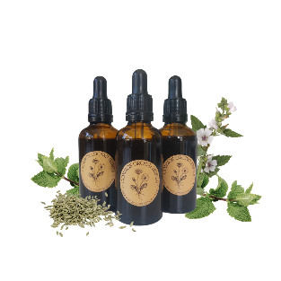
Common Ground Herbals
Patient Information Leaflet – Bloat drops (50ml Herbal blend Tincture) 2025

What is this product for?
Pinchy and bloated stomachs will love these drops. Perfect for on-the-go symptom relief. Traditionally, the herbs included in this blend are used to support sluggish and uncomfortable digestive issues. The aromatic and antispasmodic compounds in these drops can also support wind, bloating, and anxious tummies.

Ingredients
Matricaria recutita (Chamomile), Mentha X piperita (Peppermint), Foeniculum vulgare (Fennel), Althea officinalis (Marshmallow root).

Allergens
If you are allergic to any of the ingredients, please do not use this product. This product is not recommended for individuals with an Asteraceae (Sunflower) or Apiaceae (Celery) allergy. If you require more allergen information, please find the contact information at the bottom of this leaflet.

Who is this product for?
This product is suitable for individuals over the age of 12. The product is intended to help support bloating, sluggish digestion, wind and IBS symptoms associated with anxiety.

Dosage
2-4 Droppers (5-10ml), in a little water, up to Twice a Day, or When Required.
Do not exceed the stated dose.
Suggested usage: Shake before use. Use half an hour before meals or when required. Sit quietly and clear your mind, use the desired dose, under the tongue or used in a small amount of water (30ml).
Some individuals may wish to use this product neat, however this can be too strong for others. We recommend using only 30ml of water if required. The bitter notes and flavour are beneficial to the nervous system and digestion.

Potential drug interactions
These interactions have been sourced using a trusted online database available to herbalists. Some of the interactions listed are based on theoretical information and not on modern studies. Please speak to a doctor or herbalist before taking any herbal remedies if you take medications.
CNS depressants, Contraceptives, Estrogen medications, Tamoxifen, Warfarin, Anticoagulants, Ciprofloxacin, Cyclosporine, Lithium.

Ethics
The herbal tinctures used in this blend have been sourced ethically from trusted suppliers who put quality ingredients at the forefront of their work. Where possible, eco-friendly packaging has been used. This product contains no animal products nor has been tested on animals. Please recycle the packaging and this product in line with local guidelines.

Other safety information
Store away from children, in a cool, dark place. Contains alcohol.
Please consult your herbalist or healthcare professional before taking herbal medicines, especially if you are pregnant, breast-feeding, have other health conditions or taking any medications.
This product is not intended to replace professional medical advice and in an emergency you should contact 999.

Contact Information
www.commongroundherbals.com
commongroundherbals@gmail.com

Please read our Terms & Conditions at: https://www.commongroundherbals.com/policies
If you have any further questions please contact: commongroundherbals@gmail.com

