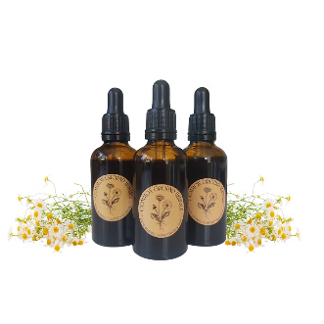
Common Ground Herbals
Patient Information Leaflet – Calm drops (50ml Herbal blend Tincture) 2025

What is this product for?
This beautiful mix is crafted using calming botanicals to help support those under stress, experiencing insomnia or anxiety and help to rebalance and restore.
Chamomile eases tension and helps the body and mind to unwind and relax. Limeflower quietens a busy mind, relaxing the heart and breath. Wood betony grounds and centres, bringing our awareness back into the body. Wild oats nourish and restore a depleted nervous system. Rose offers a gentle influence that opens the heart and encourages strength.
Used together in this herbal blend, they offer quiet resilience and inner calm. Take a moment of calm whenever you need it.

Ingredients
Matricaria recutita (Chamomile), Tilia europea (Limeflower), Stachys betonica (Wood-betony), Avena sativa (Wild oats) and Rosa damascena (Damansk Rose).

Allergens
If you are allergic to any of the ingredients, please do not use this product. This product is not recommended for individuals with an Asteraceae (Sunflower) allergy or Gluten intolerance. If you require more allergen information, please find the contact information at the bottom of this leaflet.

Who is this product for?
This product is suitable for individuals over the age of 12. The product is intended to help support restless sleep, anxiety issues, stress or to help support general well-being.

Dosage
2-4 Droppers (5-10ml), in a little water, up to Twice a Day, or When Required.
Do not exceed the stated dose.
Suggested usage: Use half an hour before bed or when required. Find a quiet area and sit focussing on your breath and clearing your mind, use the desired dose, under the tongue or used in a small amount of water (30ml).
Some individuals may wish to use this product neat, however this can be too strong for others. We recommend using only 30ml of water if required. The bitter notes and flavour are beneficial to the nervous system.

Potential drug interactions
These interactions have been sourced using a trusted online database available to herbalists. Some of the interactions listed are based on theoretical information and not on modern studies. Please speak to a doctor or herbalist before taking any herbal remedies if you take medications.
CNS depressants, Contraceptives, Estrogen medication, Tamoxifen, Warfarin, Insulin and antidiabetic drugs, Lithium, High blood pressure (BP) medication.
Caution with those who take sedatives and antihypertensive drugs. If used in conjunction with other sedatives this could suppress the CNS. Patients who take high BP meds could experience drop in BP leading to dizziness or potential loss of consciousness.

Ethics
The herbal tinctures used in this blend have been sourced ethically from trusted suppliers who put quality ingredients at the forefront of their work. Where possible, eco-friendly packaging has been used. This product contains no animal products nor has been tested on animals. Please recycle the packaging and this product in line with local guidelines.

Other safety information
Store away from children, in a cool, dark place. Contains alcohol.
Please consult your herbalist or healthcare professional before taking herbal medicines, especially if you are pregnant, breast-feeding, have other health conditions or taking any medications.
This product is not intended to replace professional medical advice and in an emergency you should contact 999.

Contact Information
www.commongroundherbals.com
commongroundherbals@gmail.com

Please read our Terms & Conditions at: https://www.commongroundherbals.com/policies
If you have any further questions please contact: commongroundherbals@gmail.com

