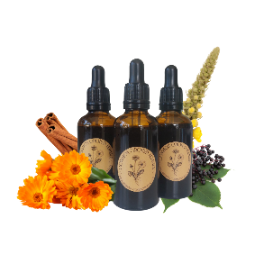
Common Ground Herbals
Patient Information Leaflet – Winter Wellness Drops (50ml Herbal blend Tincture) 2025

What is this product for?
Winter Wellness drops help to support our immune system over the colder months, Elderberry supports the immune system. Mullein helps to support congestion and coughs. Nettle is a nutritive ingredient, high in vitamins and minerals. Calendula supports the lymphatic system. Cinnamon offers a warming quality that ties the ingredients together, for a comforting blend, that supports wellbeing.

Ingredients
Sambuccus nigra fruct (Elderberry), Urtica dioica (Nettle), Verbascum Thapsus (Mullein), Calendula officinalis (Pot Marigold), Cinnamomum zeylanicum (Cinnamon).

Allergens
If you are allergic to any of the ingredients, please do not use this product. This product is not recommended for individuals with an Asteraceae (Sunflower) allergy. If you require more allergen information, please find the contact information at the bottom of this leaflet.

Who is this product for?
This product is suitable for individuals over the age of 12. The product is intended to help support immune health, lymphatic and respiratory systems over the winter months when coughs and colds are common.

Dosage
2-4 Droppers (5-10ml), in a little water, Daily.
Do not exceed the stated dose.
Suggested usage: Shake before use. Take after breakfast for a morning boost or when required.
Some individuals may wish to use this product neat, however this can be too strong for others. We recommend using only 30ml of water if required. The bitter notes and flavour are beneficial to the nervous system and digestion.

Potential drug interactions
These interactions have been sourced using a trusted online database available to herbalists. Some of the interactions listed are based on theoretical information and not on modern studies. Please speak to a doctor or herbalist before taking any herbal remedies if you take medications.
Antidiabetic drugs, immunosuppressants, diuretics, Lithium, Warfarin and Pazopanib.

Ethics
The herbal tinctures used in this blend have been sourced ethically from trusted suppliers who put quality ingredients at the forefront of their work. Where possible, eco-friendly packaging has been used. This product contains no animal products nor has been tested on animals. Please recycle the packaging and this product in line with local guidelines.

Other safety information
Store away from children, in a cool, dark place. Contains alcohol.
Please consult your herbalist or healthcare professional before taking herbal medicines, especially if you are pregnant, breast-feeding, have other health conditions or taking any medications.
This product is not intended to replace professional medical advice and in an emergency you should contact 999.

Contact Information
www.commongroundherbals.com
commongroundherbals@gmail.com
Please read our Terms & Conditions at: https://www.commongroundherbals.com/policies
If you have any further questions please contact: commongroundherbals@gmail.com

